GPT NLP Lab Assistant Group 3
Michael Fritzer, Muhammed Faseeh,
David Haybarger, Kevin Lee

Functional System Requirements

Functional System Requirements
for the
GPT NLP Lab Assistant Group 3

Team AURA

Prepared by:

Muhammed Faseeh 10/03/2025
_____________________________
Author Date

Approved by:

Michael Fritzer 12/06/2025
_____________________________
Project Leader Date

Byung-Jun Yoon 12/06/2025
_____________________________
Professor Date

Fahrettin Ay 12/06/2025
_____________________________
T/A Date

Change Record
Rev. | Date | Originator | Approvals | Description
1 | 09/30/2025 | Michael Fritzer,  Muhammed Faseeh,  David Haybarger,  Kevin Lee | Michael Fritzer,Fahrettin Ay,Byung-Jun Yoon | Draft Release
2 | 12/5/2025 | Michael Fritzer,  Muhammed Faseeh,  David Haybarger,  Kevin Lee | Michael Fritzer,Fahrettin Ay,Byung-Jun Yoon | Final Release

Table of Contents
Table of Contents ............................................................................................................... III
List of Tables ...................................................................................................................... IV
List of Figures ..................................................................................................................... V
1. Introduction …………………………………………………………………………………... 1
1.1. Purpose and Scope ……………………………………………………………………… 1
1.2. Responsibility and Change Authority ………………………………………………….. 2
2. Applicable and Reference Documents …………………………………………………... 3
2.1. Applicable Documents …………………………………………………………………... 3
2.2. Reference Documents …………………………………………………………………... 4
2.3. Order of Precedence …………………………………………………………………….. 4
3. Requirements ……………………………………………………………………………….... 5
3.1. System Definition ………………………………..…………………………………..…… 5
3.2. Characteristics ………………………………..……………………………….……….… 6
3.2.1. Functional / Performance Requirements ……………………………………….... 6
3.2.2. Physical Characteristics ………………………………………………………….… 7
3.2.3. Electrical Characteristics …………………………………………………………... 7
3.2.4. Failure Propagation ………………………………………………………………... 9
4. Support Requirements ……………………………………………………………………. 11
Appendix A Acronyms and Abbreviations …………………………………………………. 13

List of Tables
TABLE 1: Subsystem Leads ................................................................................................ 2
TABLE 2: Applicable Documents ........................................................................................ 3
TABLE 3: Reference Documents ........................................................................................ 4

List of Figures
FIGURE 1: Project Conceptual Image …………………………….......….…….…….…......... 1
FIGURE 2: Block Diagram of System ................................................................................. 5

Introduction

Purpose and Scope
The Autonomous University Robot Assistant (AURA) is an efficient and interactive system designed to support engineering students in laboratory environments where direct instructor assistance may be limited. The system provides students with real-time academic support by combining artificial intelligence, computer vision, and robotic interaction to assist with circuit troubleshooting, component identification, and guided instruction. Rather than relying solely on professors or teaching assistants, AURA allows students to receive immediate feedback and explanations during hands-on lab activities.
The system gathers data from physical circuits through integrated sensors, probing mechanisms, and a camera system. This information is analyzed by a locally hosted AI model, which delivers actionable feedback and explanations to the student. To ensure accuracy and alignment with official coursework, the system employs Retrieval Augmented Generation (RAG), allowing it to reference curated university lab manuals, SOPs, and technical documents. This ensures that responses are both conversational and grounded in approved instructional material.
The system operates as a bench-top robotic assistant designed for indoor university laboratory use. AURA supports text, voice, and image-based interaction and presents responses through an integrated touchscreen interface and audio output. The system is intended as an instructional support tool to improve student understanding, reduce delays caused by limited instructor availability, and enhance overall learning efficiency in engineering laboratory environments.
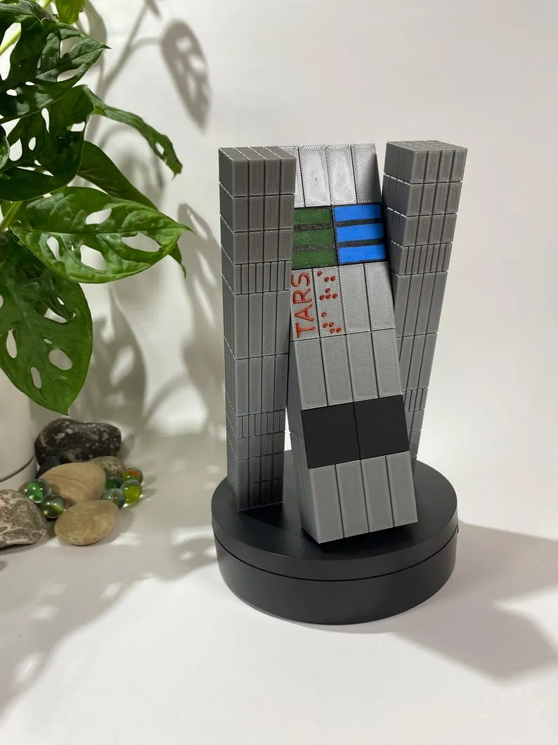
Figure 1: Project Conceptual Image

Responsibility and Change Authority
The team leader, Michael Fritzer, will be responsible for verifying all requirements of the project are met. These requirements can only be changed with the approval of the team leader and Professor Byung-Jun Yoon.

Subsystem | Responsibility
Artificial Intelligence | Michael Fritzer
Hardware & Power Systems | Muhammed Faseeh
User Interface & Web Dashboard | Muhammed Faseeh
Robotics | David Haybarger
Voice and Image Recognition | Kevin Lee
Table 1: Subsystem Leads

Applicable and Reference Documents

Applicable Documents
The following documents, of the exact issue and revision shown, form a part of this specification to the extent specified herein:

Document Number | Revision/Release Date | Document Title
DOD-HDBK-791 | 3/17/1998 | Maintainability Design Techniques Metric
MIL-HDBK-217 | Revision F – 2/28/1995 | Reliability Prediction of Electronic Equipment
MIL-HDBK-263 | Revision B – 7/31/1994 | Electrostatic Discharge Control Handbook for Protection of Electrical and Electronic Parts, Assemblies and Equipment
MIL-HDBK-338 | Revision B – 10/1/1998 | Electronic Reliability Design
IPC A-610E | Revision E – 4/1/2010 | Acceptability of Electronic Assemblies
MIL-DTL-38999 | Revision L – 5/10/2012 | General Specification for Connectors, Electrical, Circular, Miniature, High Density, Quick Disconnect (Bayonet, Threaded, and Breech Coupling), Environment Resistant, Removable Crimp and Hermetic Solder Contacts
MIL-STD-461 | Revision E – 8/20/1999 | Requirements for the Control of Electromagnetic Interface Characteristics of Subsystems and Equipment

Table 2: Applicable Documents

Reference Documents

The following documents are reference documents utilized in the development of this specification. These documents do not form a part of this specification and are not controlled by their reference herein.

Document Number | Revision/Release Date | Document Title
ESP32-TRM | 2020 | Espressif ESP32 Technical Reference Manual
MOLICEL-INR18650P26A-V2 | 2020 | Lithium-Ion Rechargeable Battery – INR18650P26A V2 Product Datasheet
IEEE Standard 802.11 | 2020 | (Wi-Fi) - Wireless LAN Communication
MCP23X17-DS | 2021 | Adafruit MCP23X17 Datasheet
LD-2015MG-DS | 2022 | Servo Motor LD-3015MG Datasheet
NVIDIA-JetsonNano-DS | 2022 | NVIDIA Jetson Nano Developer Kit Datasheet
arXiv:2410.05779 | 2024 | Retrieval-Augmented Generation for Large Language Models: A Survey
META-SAM2 | 2024 | Segment Anything Model 2 (SAM 2) — Meta AI
GITHUB-RAG-LOCAL-LLM | 2025 | Local LLM with RAG Implementation — A. Scotti
Bluepad32-LIB | 2025 | Bluepad32 Library Documentation
ALTIUM-PCB-TUT | 2025 | Altium Designer Tutorial – Creating and Configuring PCB Document

Table 3: Reference Documents

Order of Precedence
In the event of a conflict between the text of this specification and an applicable document cited herein, the text of this specification takes precedence without any exceptions.

All specifications, standards, exhibits, drawings or other documents that are invoked as “applicable” in this specification are incorporated as cited. All documents that are referred to within an applicable report are considered to be for guidance and information only, except ICDs that have their relevant documents considered to be incorporated as cited.

Requirements

System Definition
The AURA system is an autonomous, bench-top robotic assistant intended for use in university laboratory environments. It integrates artificial intelligence (AI), computer vision, multimodal input/output (I/O), embedded control, and robotic actuation to assist students with laboratory measurements, troubleshooting, and procedural guidance. The system provides instructional support through natural language interaction, physical probing and sensing, and context-aware responses derived from curated academic resources.
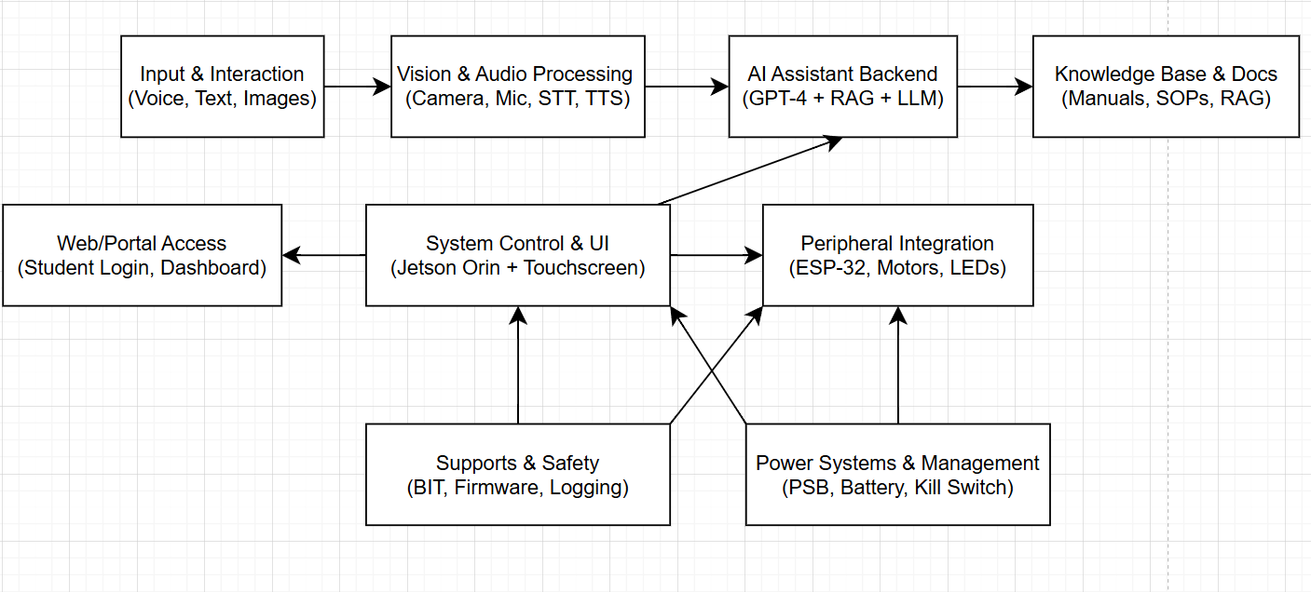
Figure 2: Block Diagram of System

At a high level, the AURA system is composed of the following subsystems (see Figure 2):
- Input and Interaction Subsystem
Accepts student queries through voice, text, and image-based inputs and serves as the primary interface for initiating interactions and uploading lab-related content.
- Vision and Audio Processing Subsystem
Performs speech-to-text (STT), text-to-speech (TTS), and image recognition using integrated cameras and microphones to support conversational interaction and circuit/component recognition.
- AI Assistant Backend Subsystem
Provides the core intelligence of the system using a locally hosted large language model (LLM) with Retrieval Augmented Generation (RAG) for context-aware instructional responses.
- Knowledge Base and Documentation Subsystem
Stores, manages, and serves curated reference material including lab manuals, SOPs, and course documents for use by the AI backend.
- System Control and User Interface Subsystem
Provides a touchscreen-based graphical user interface for direct interaction, file management, and system configuration.
- Peripheral Integration Subsystem
Managed by an ESP-32 microcontroller and supports motors, LEDs, and expressive outputs for robotic interaction and feedback.
- Support and Safety Subsystem
Provides firmware control, system logging, and Built-In Test (BIT) functionality to support fault detection, isolation, and recovery (FDIR).
- Power Systems and Management Subsystem
Supplies regulated power using battery and external power inputs, including kill switch functionality and stable power distribution to the Jetson, ESP32, and all peripherals.
- Web and Portal Access Subsystem
Provides remote access through a secure web-based dashboard that allows students and instructors to review interaction logs, upload instructional documents for RAG usage, and monitor system activity.

Characteristics

Functional / Performance Requirements

Query Response
The system shall process and provide an initial response to student queries using natural language within 3 seconds for text-based input and within 5 seconds for audio or image-based input under nominal operating conditions.

Rationale: This response time ensures minimal disruption to laboratory workflows and supports real-time system usability.

Knowledge Retrieval
The system shall employ Retrieval Augmented Generation (RAG) to retrieve supporting information from curated course documents, laboratory manuals, and Standard Operating Procedures (SOPs) for at least 90% of student queries under nominal operating conditions.

Rationale: This ensures that the majority of system responses are grounded in authoritative academic material and aligned with official instructional content.

Multimodal Input
The system shall support text-based, voice-based, and image-based input as user interaction modalities.

Rationale: This increases system accessibility and provides flexible interaction for diverse student needs.

Session Logging
The system shall log all user interactions, including student queries and corresponding AI responses, to a local database with associated timestamps.

Rationale: This enables instructors to review student interactions for grading, feedback, and troubleshooting purposes.

Physical Characteristics

Mass
The total mass of the Autonomous University Robot Assistant (AURA) system shall be less than or equal to 7 kilograms.

Rationale: This ensures the system can be easily placed on and removed from a standard laboratory workbench by a single user without specialized lifting equipment.

Volume Envelope
The volume envelope of the Autonomous University Robot Assistant (AURA) system shall be less than or equal to 36 inches in height, 8 inches in width, and 12 inches in length.

Rationale: These dimensional limits ensure compatibility with standard university laboratory workbenches and allow the system to operate without obstructing surrounding equipment or student workspace.

Electrical Characteristics

3.2.3.1. Inputs
- The presence or absence of any combination of the input signals in accordance with ICD specifications applied in any sequence shall not damage the Autonomous University Robot Assistant System (AURA), reduce its life expectancy, or cause any malfunction, either when the unit is powered or when it is not.

- No sequence of command shall damage the Autonomous University Robot Assistant System, reduce its life expectancy, or cause any malfunction.

Rationale: By design, this limits the chance of damage or malfunction due to user or technician error.

Power Consumption
The maximum power consumption of the AURA system shall not exceed 100 watts under full operational load, including Jetson compute, ESP32 peripherals, servo motors, sensors, and user interface operation.

Rationale: This limit accommodates worst-case operation of all major subsystems (Jetson, servos, and ESP32) while remaining compatible with typical laboratory bench supplies, battery packs, and AC/DC adapters.

Input Voltage Level
The system shall operate from a 4-cell lithium-ion battery pack with a nominal voltage of 14.8 VDC and an allowable operating input range of 12.0 VDC to 16.8 VDC at the power entry module (PEM).

For wall-powered operation, the system shall accept input from a regulated AC/DC power adapter providing 19–24 VDC, which shall be converted by an internal DC/DC stage to the required system rails (e.g., Jetson, ESP32, and servos).

Rationale: This input range matches the expected voltage profile of the selected 4-cell Li-ion pack (MOLICEL INR18650 series) while ensuring compatibility with common bench-top AC/DC adapters and providing sufficient headroom for internal buck regulation to sensitive subsystems.

Input Noise and Ripple
The AURA system shall operate correctly when supplied by typical laboratory DC power sources and battery outputs that meet the voltage range specified in 3.2.3.1.2 and exhibit no more than 5% peak-to-peak ripple on the DC output.

Rationale: This requirement ensures the system remains robust to normal levels of power-supply noise present in bench-top and battery-powered laboratory environments.

External Commands
The AURA system shall operate correctly when supplied by either the internal 4-cell lithium-ion battery pack (12.0–16.8 VDC) or a regulated AC/DC laboratory power adapter (19–24 VDC), provided that the input voltage ripple does not exceed 5% peak-to-peak of the nominal input voltage.

Rationale: This requirement ensures robust system operation under normal laboratory battery and bench power conditions without requiring precision noise characterization equipment during validation.

Outputs

Data Output
The AURA system shall output all relevant system data, including student query information, AI-generated responses, sensor measurements, system status, and operational logs, to the onboard touchscreen user interface and the web/portal interface.

Rationale: This ensures that users can view real-time responses locally while also enabling remote review of system activity through the web portal.

Diagnostic Output
The AURA system shall provide a diagnostic output interface for firmware development, debugging, system monitoring, and data logging through the USB service port and web-based diagnostics dashboard.

Rationale: This allows developers and maintenance personnel to perform troubleshooting, software updates, and system validation efficiently.

Connectors
The AURA system shall utilize keyed, locking electrical connectors rated for the maximum operating voltage and current of each power and signal interface. Power connections shall use high-current locking connectors (e.g., XT60, XT30, or equivalent), while signal and data connections shall use JST, USB, or equivalent laboratory-rated connectors.
All external connectors shall be selected to prevent incorrect mating, reduce the risk of accidental disconnection during normal operation, and ensure safe operation in a university laboratory environment.
Rationale: These connector types provide sufficient electrical reliability, mechanical retention, and user safety for bench-top laboratory operation without the cost and complexity of military-grade connector systems.

Failure Propagation
The Autonomous University Robot Assistant (AURA) system shall be designed such that no single internal subsystem failure shall propagate outside of the AURA system boundary or cause damage to external equipment, users, or the laboratory environment.

Rationale: This ensures that internal faults remain contained within the system and do not create hazards to surrounding lab equipment or users.

Failure Detection, Isolation, and Recovery (FDIR)
The AURA system shall implement Failure Detection, Isolation, and Recovery (FDIR) mechanisms to detect internal faults, isolate affected subsystems, and restore safe system operation when possible.

Rationale: FDIR ensures continued safe operation and allows the system to recover gracefully from internal faults without requiring immediate human intervention.

Built In Test (BIT)
The AURA system shall include a Built-In Test (BIT) capability that performs automated health checks on critical subsystems during system startup and periodic operation.

Rationale: BIT enables early detection of hardware and software failures and supports preventive maintenance.

BIT Critical Fault Detection
The BIT shall detect critical system faults with a probability of detection of at least 95 percent.

Rationale: This detection rate provides a high level of confidence that major system failures will be identified quickly.

BIT False Alarms
The BIT shall maintain a false alarm rate of less than 5 percent.

Rationale: This prevents unnecessary system interruptions and reduces maintenance burden due to incorrect fault indications.

BIT Log
The BIT shall log the results of each test, including time of occurrence, subsystem affected, and fault status, to non-volatile system memory for later retrieval by maintenance personnel..

Rationale: Logged BIT data enables effective troubleshooting and long-term reliability analysis.

Isolation and Recovery
Upon detection of a fault, the AURA system shall isolate the affected subsystem and attempt automated recovery through controlled reset, subsystem disablement, or safe-mode operation, depending on fault severity.
If automated recovery is not successful, the system shall enter a safe operational state and notify the user through the touchscreen and web/portal interface.
Rationale: Isolation and controlled recovery prevent cascading failures while ensuring safe behavior during abnormal operating conditions.

Support Requirements
The Autonomous University Robot Assistant (AURA) system shall be delivered with all necessary hardware, software, and documentation required to ensure proper operation within a university laboratory environment. Support requirements include the following:
4.1. Host Computing Requirements
- A laptop or workstation capable of running Linux or Windows with Python 3.10 or later to support development, debugging, and integration testing with the Jetson Orin Nano.
- Reliable internet access for software package updates and retrieval of external reference materials, including academic papers and updated RAG datasets.
4.2. System Documentation
The AURA system shall be delivered with the following documentation:
- A User Guide detailing startup, shutdown, and normal operating procedures.
- A Maintenance Guide for performing hardware checks (servo calibration, probe reel tensioning, battery replacement) and software updates.
- Source code repositories and hardware schematics provided for continued development, maintenance, and troubleshooting.
- Internet access for software updates and reference material retrieval.
4.3. Technical Support
- During the capstone project lifecycle, the development team shall provide integration support, bug fixes, and system updates.
- After project delivery, the system shall be designed to be self-sufficient, with documentation enabling independent maintenance by future students or faculty.
4.4. Maintenance
- Design documentation and spare components (e.g., servo motors, probe tips, and cabling) shall be provided to support minor repairs.
- The system design shall emphasize modularity, allowing individual subsystems (robotics, AI compute, probe assemblies) to be replaced or upgraded independently.

4.5. Issue Resolution
- Fault detection and logging shall be supported through onboard diagnostics and system logs.
- Troubleshooting procedures shall be documented, including:
- Software recovery (reflashing the Jetson Orin Nano image, resetting ESP32 controllers)
- Hardware resets (probe arm reel disengagement, servo recalibration)

Appendix A: Acronyms and Abbreviations
AI Artificial Intelligence
AURA Autonomous University Robot Assistant
BIT Built-In Test
CCA Circuit Card Assembly
EMC Electromagnetic Compatibility
EMI Electromagnetic Interference
EO/IR Electro-optical Infrared
FDIR Failure Detection, Isolation, and Recovery
FOR Field of Regard
FOV Field of View
GPS Global Positioning System
GPT Generative Pretrained Transformer
GUI Graphical User Interface
Hz Hertz
ICD Interface Control Document
kHz Kilohertz (1,000 Hz)
LCD Liquid Crystal Display
LED Light-emitting Diode
LLM Large Language Model
mA Milliamp
MHz Megahertz (1,000,000 Hz)
MTBF Mean Time Between Failure
MTTR Mean Time To Repair
mW Milliwatt
NLP Natural Language Processing
PCB Printed Circuit Board
PSU Power Supply Unit
RAG Retrieval Augmented Generation
RMS Root Mean Square
SAM Segment Anything Model
SOP Standard Operating Procedure
STT Speech-to-Text
TA Teaching Assistant
TBD To Be Determined
TTL Transistor-Transistor Logic
TTS Text-to-Speech
UI User Interface
USB Universal Serial Bus
VME VERSA-Module Europe

